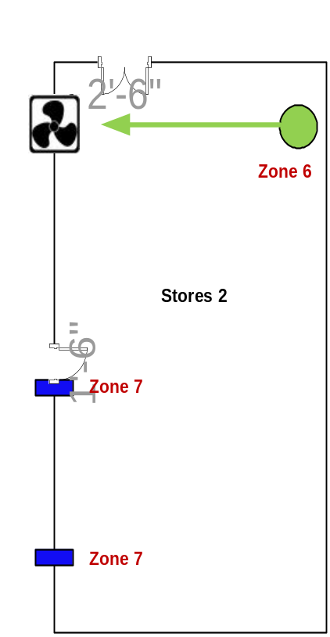Indoor PIR Motion Sensor Heavy Duty Magnetic Contact
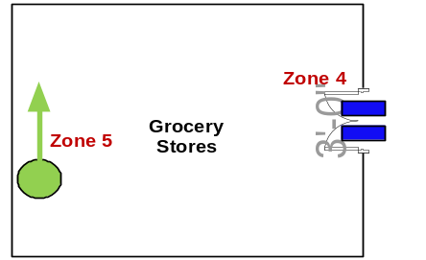

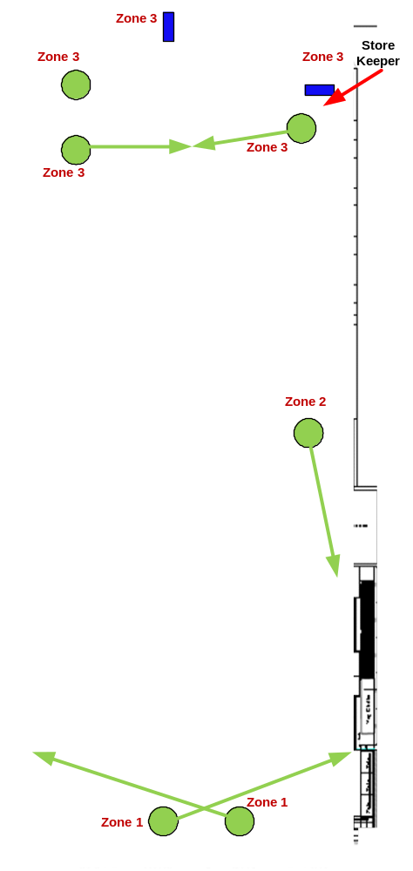

Customer Name | Keells Super – Union Place
Drawing Title | IDS
Issue No | 299-15
Issue Date | 28/11/2015
Revision No
Revision Date
Created By | Ajith Fernando
Approved By

